Vortex imprinting plates
These Imprinting Plates are especially useful in generating Scalar Waves and Scalar Wave research. In physics, a scalar is a simple physical quantity that is not changed by coordinate system rotations or translations. A Scalar Wave propagates through the dimensional time, but not through the dimensional space. Scalar Waves form nonlocal potential energy, carry information and have fractal structure, and do not decay over distance. Scalar Waves store energy and information in a dimension "outside of our 3D space" and the stored energy can be released by "closing the circuit" in our 3D dimension.
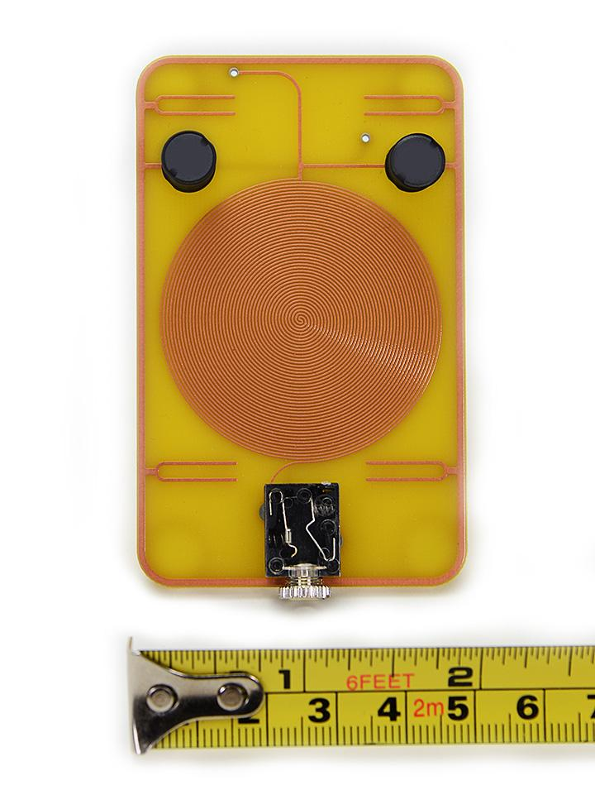
https://www.quantumbalancing.com/imprintingplates.htm

Chi scalar generator
http://www.biznet1.com/matterenergizer/chi-generators.html

Quadrifilar scalar coil
http://www.berkanapath.com/radionics/171/scalar-coil-experiment/

